Assessing the impact of increasing education provision on EU productivity

Jack O’Callaghan

University of Kent

[jno6@kent.ac.uk](mailto:jno6@kent.ac.uk)

Assessing the impact of increasing education provision on EU productivity

# Introduction

Over the past 50 years, there has been a significant expansion in provision of education across economically developed countries. In the early 1960s, very few students were able to access higher education, and even secondary education was unavailable to most young people in many countries.[1]

Since then, we have seen large expansions in education provision, giving rise to the question: “has the increase in education provision in economically developed countries positively impacted nations’ productivity?”. This is of particular importance to policymakers and politicians, to inform decision-making around the long-term impact of changes to provision of education. Due to data limitations, this analysis focuses solely on EU nations, as well as the United Kingdom.

# Data

My data are panel data of economic and educational variables for 22 European countries between 1970 and 2015. The data sets used in this analysis can be obtained using either the original source link or in the GitHub repository below. The R script used to produce the combined data set can be examined using the GitHub repository link below.

Using figure 1 below, we can identify two key trends in the average number of years of education over time. Firstly, we have seen a significant rise in the average number of years of education over the past 45 years examined. Secondly, the data appears to have become more leptokurtic over time, as the number of years in education has become more standardised across nations. This might be a potential source of heteroscedasticity within models, as error sizes might increase over time, and may imply a need for heteroscedasticity-robust (HAC) standard errors in later models.

## Figure 1: Change in the distribution of average years of education over time

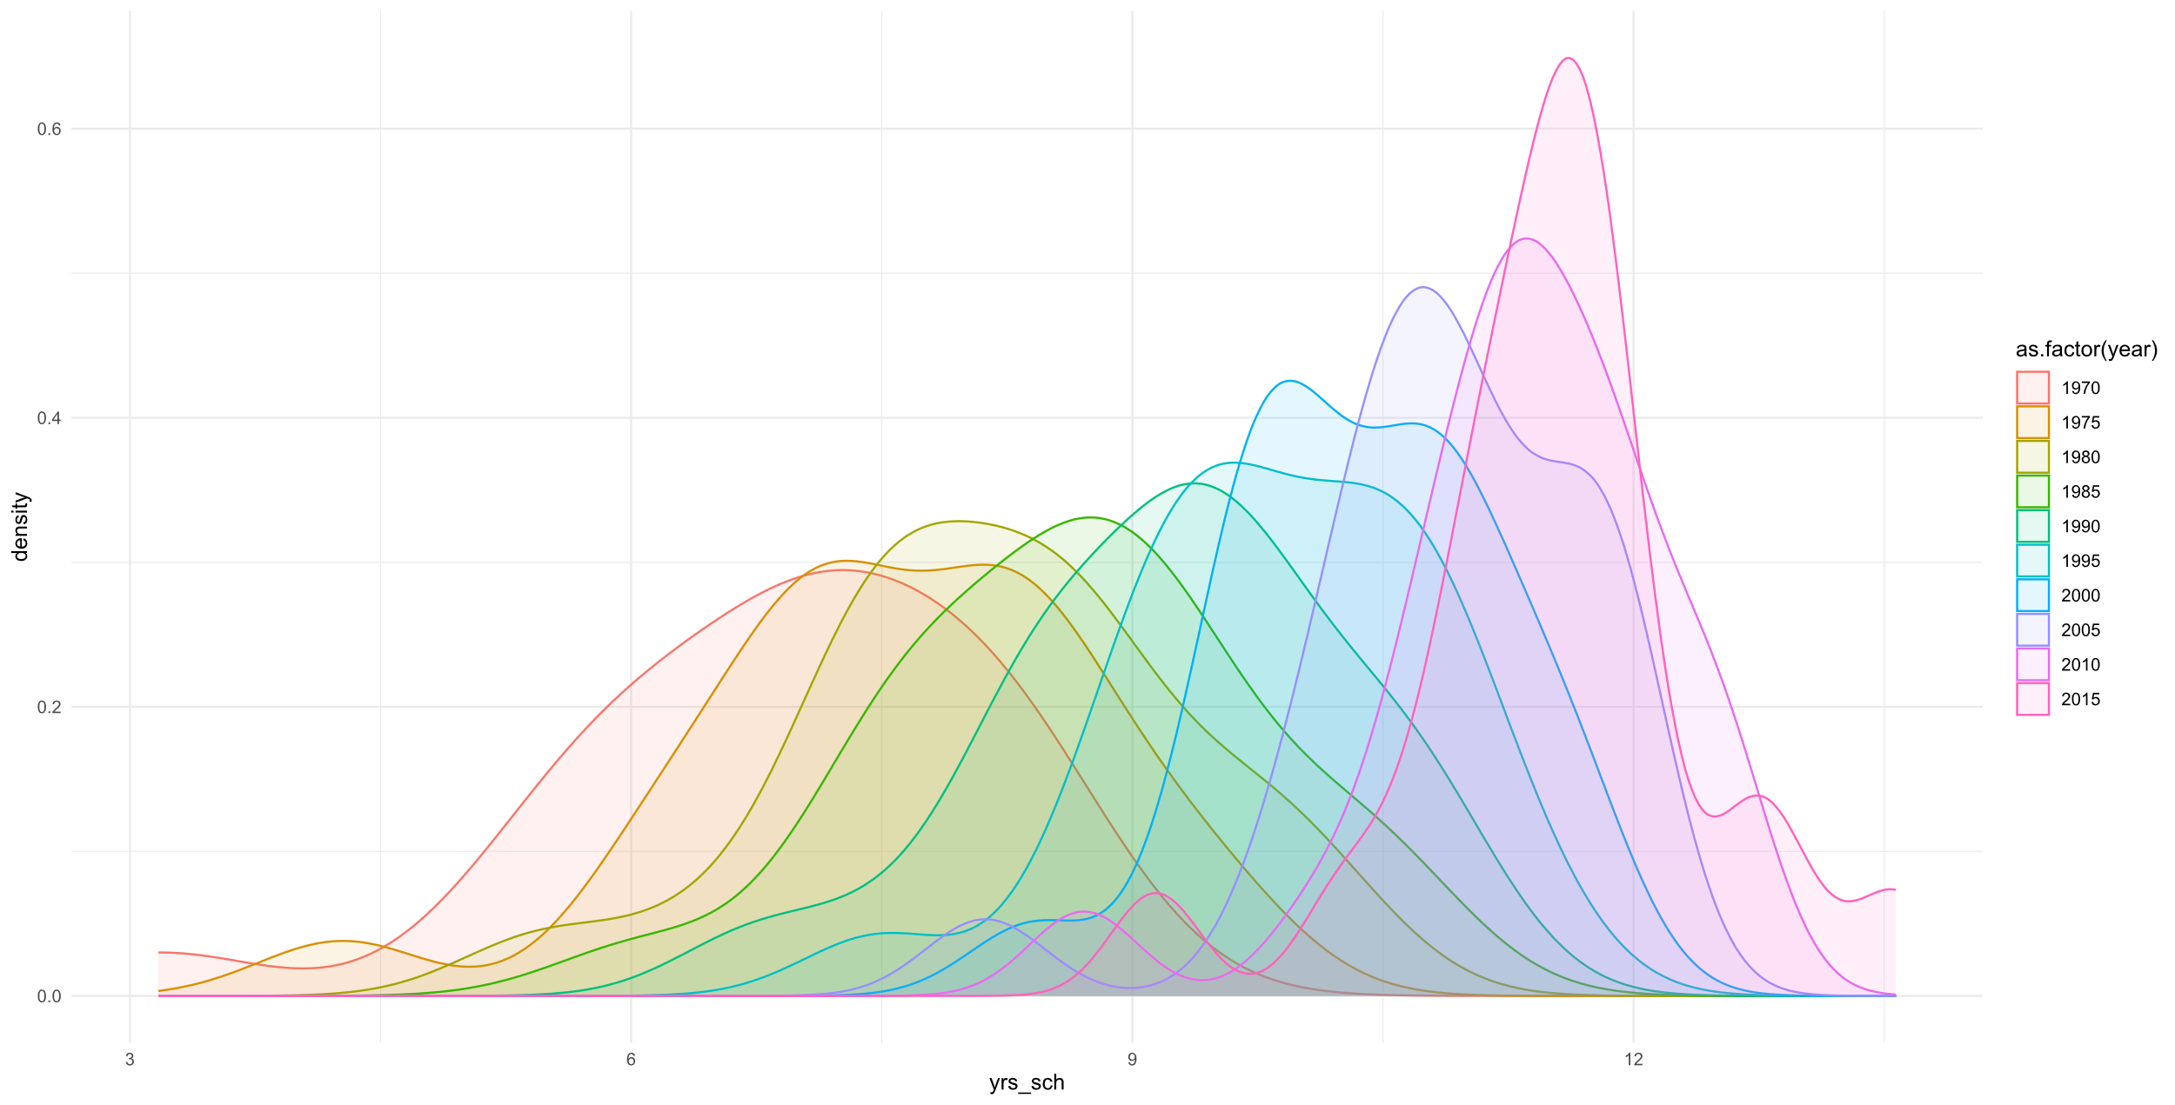

It also appears that there is a strong relationship between the number of years of education and GDP output per capita, with 40% of the variance in GDP output per capita explained by the average number of years of education. However, this relationship may be subject to some collinearity, where the number of years of education also increases as countries become wealthier, meaning that we must consider a wider range of factors than simply average years of education.

## Figure 2: Years of Education against GDP Output per Capita

From Table 1 below, we can see that there is a large amount of variation in GDP output per capita between countries and over time, as represented by rgdpo.pop. Furthermore, as shown above, there seems to be very little skew to the data for the number of years of education, with very little difference between the mean and median values.

## Table 1: Descriptive Statistics

|  |  |  |  |  |  |  |  |
| --- | --- | --- | --- | --- | --- | --- | --- |
| **Variable** | **Minimum** | **1st Q.** | **Median** | **Mean** | **3rd Q.** | **Maximum** | **Standard Deviation** |
| rgdpo.pop | 3,002.00 | 15,534.00 | 23,531.00 | 25,538.00 | 33,447.00 | 82,382.00 | 14,031.57 |
| log.rgdpo.pop | 8.01 | 9.65 | 10.07 | 9.99 | 10.42 | 11.32 | 0.60 |
| yearorig | 0.00 | 10.00 | 22.50 | 22.50 | 35.00 | 45.00 | 14.40 |
| yrssch | 3.17 | 8.16 | 9.64 | 9.45 | 10.93 | 13.57 | 1.84 |
| voc | 0.00 | 0.00 | 0.50 | 0.50 | 1.00 | 1.00 | 0.50 |
| vocpc | 1.30 | 16.66 | 27.72 | 27.25 | 34.85 | 69.01 | 13.47 |
| ctfp | 0.45 | 0.76 | 0.87 | 0.88 | 0.98 | 1.44 | 0.18 |

From a visual examination of model 4’s residual plot, the data appears to be homoscedastic. However, from the White’s Test, we know that this data is heteroscedastic. This suggests that there may be a more complex non-linear relationship between the independent variables as modelled and the variance of the residual plot, and that our log-log model form might not be the most effective form. From a review of the variables in model 4, it is not entirely clear what is driving this disparity, but this is one area of the final modelling that a future paper may wish to address.

## 

## References

Penn World Tables 10.01: <https://www.rug.nl/ggdc/productivity/pwt/?lang=en>

Barro and Lee Educational Attainment Data: <http://www.barrolee.com/>

World Bank Education Statistics: <https://datatopics.worldbank.org/education/>

US GDP Implicit Price Deflator Data: <https://fred.stlouisfed.org/series/GDPDEF/>

Repository for Data Reproduction: <https://github.com/jack-n-ocallaghan/ecox-5004-analysis>

# Methodology

This paper considers if, when accounting for a variety of confounding factors, an increase in the average number of years a citizen spends in education leads to an increase in productivity, as measured by GDP output per capita.

The originally intended scope of this analysis included 28 European nations (the 27 EU member states plus the United Kingdom), to produce generalised estimates of the impact of an additional year of education on productivity. However, due to data limitations, this analysis only covers 22 of those nations. These nations were chosen due for their generally rich provision of historical economic and educational data, although future analysis might attempt to build on this by broadening the scope of the data used. Further details of those nations excluded in this analysis can be found in the technical annex.

To compare the impact of education on productivity across multiple countries and over time, a panel data format was constructed. There is a reporting lag for some of the variables used, and the average number of years of education was only reported in five-year intervals. Therefore, the analysis shown covers the period 1970-2015 in five-year intervals.

Model estimates for this analysis were produced using a Pooled OLS approach. This method was selected as it allows us to consider the broad impact of an additional year of education in a straightforward way and does not consider country-specific effects. It is therefore important to caveat that these results represent generalised results for the impact of education, and coefficients might vary in scale by country. Do OLS assumptions hold?

## Table 2: Model Descriptions and Formulae

|  |  |
| --- | --- |
| **Model Description** | **Model Formula** |
| Model 1 - Pooled OLS with core variables | rgdpo.pop = B0 + B1·yearorig + B2·yrssch + B3·voc + |
| Model 2 - Pooled OLS with core variables and ctfp | rgdpo.pop = B0 + B1·yearorig + B2·yrssch + B3·voc + B4·ctfp + |
| Model 3 - Pooled OLS with log core variables, but share of vocational students squared | ln(rgdpo.pop.roll) = B0 + B1·ln(yearorig) + B2·ln(yrssch) + B3·vocpc2 + B4·ln(ctfp) + $ε$ |
| Model 4 - Pooled OLS with all variables in log form | ln(rgdpo.pop.roll) = B0 + B1·ln(yearorig) + B2·ln(yrssch) + B3·ln(vocpc) + B4·ln(ctfp) + $ε$ |
| Model 5 - Pooled OLS regression model, with all variables in log form and a dummy variable for 2010 | ln(rgdpo.pop.roll) = B0 + B1·ln(yearorig) + B2·ln(yrssch) + B3·ln(vocpc) + B4·ln(ctfp) + B5· D2010 + |

Going forwards, the above models will be referred to in shortened form (e.g., ‘model 5’). Out first step was to consider construction of a baseline model for this analysis. For this, we constructed model 1, which was a simple linear regression of rgdpo.pop against yearorig, yrssch, and voc. We then also constructed a second version, model 2, which also included the variable ctfp to account for changes in total factor productivity over time. Model 2 had a higher adjusted R2 value than model 1 (0.614 against 0.475), and ctfp was found to be significant at the 90% significance level. Therefore, we considered model 2’s more complete set of core variables to be ideal.

The next step was to examine the voc variable more closely. Although the value was not statistically significant at the 90% significance level, with p-values of 0.16 (model 1) and 0.19 (model 2) respectively, it was still relatively close to the threshold. Additionally, alongside policy implications of spending more time in education, it might be useful to have some idea of the impact of a more vocational style of education, even if tentative. We therefore kept the vocational variable in, switching to vocpc in the hope of better capturing more of the variance in productivity than was achieved using voc.

We then tested for autocorrelation using the Durbin-Watson (DW) test. For both models the DW statistic was in the zone of indecision, meaning that we are not able to not reject or reject the presence of autocorrelation.

Additionally, we also tested for heteroscedasticity using White’s test, which concluded that there was heteroscedasticity present in the data. We attempted to reduce these issues using log-transformed variables, which had limited positive impact.

After implementing log-transformed variables, we also implemented heteroscedasticity-robust (HAC) standard errors, and two more changes. The first was to switch from rgdpo.pop to rgdpo.pop.roll, which represents the five-year rolling average of GDP output per capita. This is useful given our five-year restriction in variable sampling, as it reduces the risk of recessionary declines in GDP producing biased coefficient estimates. The second was to switch from voc to vocpc for the reasons outlined above.

Models 3 and 4 were then produced. Given the log-log form of these models, this also gave the advantage of making it much simpler to interpret model coefficients. For instance, from model 4 we can see that a 1% increase in yrssch will lead to a 0.69% increase in GDP output per capita, when accounting for factors such as changes in total factor productivity and vocational offering. [Add more about model 3 vs model 4?].

We then also produced model 5, which included a dummy variable for the year 2010 to control for the well-documented negative impacts of the 2008 financial crisis on GDP output per capita.[2] However, this produced a counter-intuitive result, suggesting that GDP output per capita was above-trend in 2010. Multiple empirical hypotheses were considered for this result, such as the theory that the per capita GDP data used might only include employed persons, however none appeared to explain this coefficient. Because of this, model 4 is considered the preferred model of those produced.

# Reporting

## Table 3: Summary of model coefficients

|  |  |  |  |  |  |
| --- | --- | --- | --- | --- | --- |
|  | Model 1 | Model 2 | Model 3 | Model 4 | Model 5 |
| constant | (−) 934 | (−) 26,984*** | 7.64*** | 7.59*** | 7.71*** |
| yearorig | 508*** | 464*** | 0.33*** | 0.33*** | 0.31*** |
| yrssch | 1,488** | 1,572*** | 0.70*** | 0.70*** | 0.66*** |
| voc | 1,973 | 1,606 | -- | -- | -- |
| vocpc | -- | -- | 0.00 | 0.02 | 0.02 |
| ctfp | -- | 30,131*** | 1.11*** | 1.11*** | 1.12*** |
| D2010 | -- | -- | -- | -- | 0.16** |

Before interpreting the above, it is important to note that due to the difference in model structure between models 1 and 2 and models 3 to 5, the scale of coefficients between these two groups of models is not directly comparable.

Additionally, given that later model specifications (model 3 onwards) were more consistent and better captured the variance in GDP output, this section focusses solely on these models. Our estimates suggest a 10% rise in the average number of years spent in education leads to between a 6.6% and 7.0% rise in GDP output per capita holding all else equal.

Additionally, we found no statistically significant link in this analysis between the type of education provided and GDP output per capita. However, it is important to caveat this finding by emphasising that this analysis was not able to implement lagged variables due to limited sample size.

There was a strong positive link between both increasing total factor productivity and the years since 1970 and GDP output per capita.

# Conclusion

This paper examined the relationship between the number of years spent in education and productivity, as measured by GDP output per capita, across EU nations. The preferred, model 4, was a Pooled OLS model, of the form:

ln(rgdpo.pop.roll) = B0 + B1·ln(year_orig) + B2·ln(yrs_sch) + B3·ln(voc_pc) + B4·ln(ctfp) + ε

Our modelling estimates that a 10% rise in the average number of years spent in education is associated with between a 6.6% and 7.0% rise in GDP output per capita, holding all else equal. This result can help to inform educational policymaking and appraisal but represents a generalised relationship between education and productivity across European nations, not a hard-and-fast relationship between the relevant factors across all nations.

It is important to state that the size of the effect mentioned is likely to vary significantly across different countries, depending on a variety of factors. This analysis also considers the impact of education solely in terms of the change in number of years spent in education. Other factors, such as the quality and type of educational programmes offered, are important considerations when designing education policy.

A future analysis might expand on this analysis by sourcing a more detailed set of the data for the average number of years education, this allowing for a move from five-yearly to annual panel data. What is more, there are some variables that this analysis was not able to cover due to time limitations that might improve the robustness of these findings, including adding a qualitative variable for increased female participation in the labour force over time, and the impact of other core economic variables, such as exports and foreign direct investment, on GDP output.

1. Gurría, A. (2011) Editorial: Fifty years of change in education [Online], p. 1. Available from <https://www.oecd.org/education/skills-beyond-school/48642586.pdf> [Accessed 16th November 2023]
2. Oulton, N. and Sebastiá-Barriel, M. (2013) Long and short-term effects of the financial crisis on labour productivity, capital and output [Online], p. 2. Available from <https://www.bankofengland.co.uk/working-paper/2013/long-and-short-term-effects-of-the-financial-crisis-on-labour-productivity-capital-and-output> [Accessed 16th November 2023]